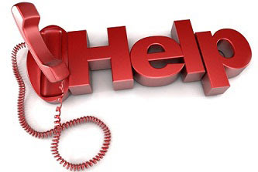

**Life Line:**

Call 211 or 585-275-5151

**NYS  Project Hope Emotional Support:**

1-844-863-9314

**Crisis Text Line:**

TEXT GOT5 to 741741

**National Suicide Prevention Lifeline:**

1-800-223-TALK (8255)

**Trevor Lifeline:**

1-866-488-7386

**Trevor Text**:

Text START to 678678

**NYS Office of Mental Health Customer Relations:**

1-800-597-8481